  
  
**The Broadsheet Vol. 47, No 4 January 2025**  
**President‘s Message**  
**By Regina M Griego**  
We are in the midst of Contest Season! We’ve been receiving Professional Communication Contest entries, High School Communication Contest entries, Zia Book Award entries. In addition, we just kicked off our Communicator of Achievement Award contest.   
We need all NMPW members to spread the word about these opportunities to recognize commutators.  
We have a great program for our 2025 NMPW Annual Conference on March 21-22, 2025 at Isleta Resort and are very excited about our speakers, panelists, and workshop instructors. This conference is a wonderful opportunity to reconnect with other communications professionals, make new contacts, and learn something new. Jay Newton-Small, the Executive Editor of the Albuquerque Journal will give a keynote on Saturday morning.   
This issue of the Broadsheet will highlight some of the panels and features of the conference. Our banquet speaker is a past Albuquerque Poet Laurette, Michelle Otero. Her work at Arte Sana is about using art to heal. She is a beloved gem in our community and I am very happy that she will be joining us. We are reserving ample time during the banquet to honor our Communication Contest winners and provide the recognition they deserve. This recognition is central to our mission as an organization.  
Lastly, we have settled on our new logo. You may have noticed it as the header for this article. We welcome any feedback on our new logo and plan to showcase it at our NMPW Annual Conference. Our new website will go live before the conference and we are so excited to refresh our image as we begin 2025! We have a great legacy entering our 76th Anniversary Year and we look forward to continuing our mission to recognize journalistic talent (communicators of all sorts) and support First Amendment rights. As always, feel free to e-mail me at [president@newmexicopresswomen.org](mailto:president@newmexicopresswomen.org).  
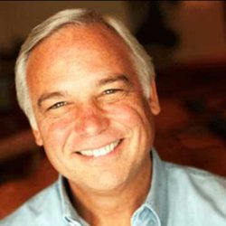  
**Creating a Multi-media Guardianship Community**By Léonie Rosenstiel  
Our first Conference panel on March 21 2025 is a hybrid chaired by NMPW vice-president Léonie Rosenstiel, Ph.D., M.P.H. It will consider the problems now experienced in adult guardianship and how the press can facilitate progress toward solving them. Joining Léonie are  
Jack Canfield (the Chicken Soup for the Soul creator), Jay Newton-Small (the Albuquerque Journal’s new Executive Editor), and Michael Brasher (Chair of the Board of KNME).   
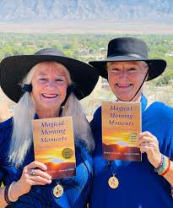  
**Photography and Poetry of Sunrises in New Mexico Make Magic  
By Jasmine Tritten**Our first Annual Conference Workshop (on March 21 2025) will be a collaboration between multi-award-winning presenters Jasmine Tritten and Wanda W. Jerome. This experiential, hands-on workshop is planned to inspire artistic expression among experienced and novice photographers and poets alike. Participants interested in  
learning more about the combination of photography and poetry for personal enjoyment and professional publication are encouraged to attend.  
Key themes of this hands-on workshop:  
• Artistic Expression and Self-care: Morning Meditations in Nature  
• Taking Inspirational Photographs  
• Today’s Poet: Consciously Creative  
• Our Experiential Activity: Calling the Muse, Writing and Sharing Together  
A variety of creatively matched color photographs and poems have been selected from  
the presenters’ recent publication, Magical Morning Moments: Awakening to Love and  
Light – recipient of the Gold Medal for Poetry Book Award from the Military Writers  
Society of America (2024).  
  
Workshop participants will compose poetry based on their responses to viewing several  
brilliant color photographs of Sandia Mountains morning sunrises. An open sharing  
session will follow in which each participant will be encouraged to share aloud their  
poem or poems.  
  
Each participant will be provided with a journal and pen for the activity upon entry into  
the workshop, which is theirs to keep upon completion.  
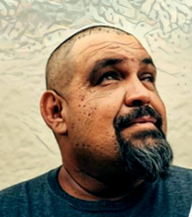  
**Reception Guest Marcial Delgado: Voices of the Barrio Slam Poetry**By Regina M. Griego  
Albuquerque poet Marcial Delgado hosts and curates Voices of the Barrio Open Mic Poetry at El Chante: Casa de Cultura in downtown Albuquerque. In 2017 Marcial Delgado became the ABQ Poetry Slam Champion. I have had the privilege to attend and participate at Voices of the Barrio Open Mic Poetry and I am always moved and astounded by the depth and simplicity of Marcial’s poetry. He also promotes and mentors other poets and competes nationally in Slam Poetry Events.   
  
Marcial is a master orator and I am delighted that he said yes to perform his poetry at our 2025 NMPW Annual Conference. His poetry is firmly rooted in community and family. There is a groundedness in his poetry and he exemplifies the direct, clean, unfussy language of a working-class approach. He is a strong performer, who can command a stage with not only his physical presence, but his delivery and the heart of his message. I consider Marcial a friend and unique voice in our community.  
  
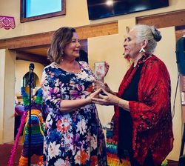  
**Panel on Healing Generational Trauma Through Artistic Expression**By Regina M. Griego  
Regina was able to attend Denise’s book launch and present her with her with the 2024 NMPW Courageous Communicator Award that she was unable to accept at last year's conference.  
On Saturday morning Denise Chávez, Chicana author, bookseller, and activist from southern New Mexico will be joining New Mexico Press Women’s President, Regina Griego and Josie Méndez-Negrete author, publisher, Professor Emerita of Sociology in Mexican American Studies at University of Texas, San Antonio in this deeply personal and transformative panel.  
Each panelist has written and engaged in artistic expressions to heal and lead others through generational trauma and grief. Regina was featured at last year’s 75th NMPW Conference in an interview about her book *Sins of the System: Trauma, Guns, Tragedy, and the Betrayal of Our Children*. It is a book she wrote after she lost five family members in a mass shooting committed by her troubled nephew.  
Denise continues to write about families in New Mexico and the U.S. Border, books that offer insight into healing generational trauma endemic in Latino communities, a result of myriad and complex forms of oppression, racism, lack of opportunity and education. Her most recent novel, *Street of Too Many Stories* was published last May by Conocimientos Press in San Antonio.  
In Chávez's novel, polyvocal narrators recount, examine, and analyze the complexities of life found among four families who live on Encantada Street in the town of Encantada, New Mexico. As a witness, Encantada Street brings to life the residents’ daily experiences, recalling the fierce, the beautiful, the painful, and the ultimately transformative experiences of their lives in this theatrical opera of voice and spirit.  
Josie Méndez-Negrete is the author of *Las Hijas de Juan: Daughters Betrayed*. Published by Duke University Press it is among the deepest and most transformative of books on family healing and documents the history of her own family's journey of healing.  
  
The panelists will share their journey of processing, writing about, and committing to sharing their profound personal journeys with the audience.  
  
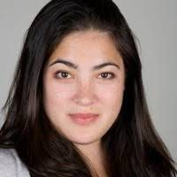  
**Interview with Jay Newton-Small, Our Keynote Speaker**By Léonie Rosenstiel  
The new Executive Editor and Vice-President of the Albuquerque Journal sat down with me to answer a few questions.   
Q: I think most people would say that you’re cosmopolitan and a world traveler and an experienced journalist, but what’s your description of yourself?  
A: I would describe myself as a curious person who likes to go and see things for herself.  
Q: All over the world?  
A: I’ve been lucky enough to have a career that, between Bloomberg and Time, has allowed me to cover stories, actually on six continents, and across a variety of countries, whether I was traveling with the President and covering the White House, or whether I was doing magazine stories, more in depth, in the Middle East and Europe. [(Click here to see the complete interview.)](https://wp.me/P29ohT-14e)  
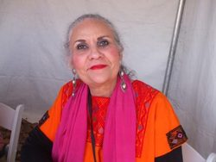  
**TrueVoice Writing Workshop**By Regina M. Griego and Denise Chávez  
Denise Chávez and Josie Méndez-Negrete will co-lead a writing workshop that will allow participants to connect with their True Voice. In this intensive GIVE IT UP, MAMA, workshop you will have the opportunity to explore your True Voice in a series of fun and expansive writing exercises and prompts led by the co-workshop leaders.  
In this workshop you will have the opportunity to explore your True Voice, and you will be given insights as to how to write in such a way that it will resonate in a new and profoundly humanistic way. We will share story as we celebrate each other's True Voices.  
Bring a journal, a laptop, your favorite purple pen, and your open heart.  
I (Regina) have read several of the author's books and find myself resonating with the characters. Through empathy and observation, you hear your uncle or aunt, your mother, father, their voices drifting in the air, waiting to be heard and acknowledged in their quiet desperation or exasperation.  
  
Denise believes a writer is always hopeful that their attention and their vision will connect with the Spirits and that we will join together in miraculous union. For writing has as its core Truth. Writing, she says, "Sets the Spirits in Motion to be Freed."  
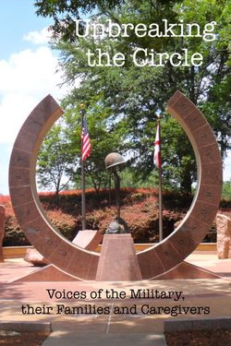  
**An Invitation to Contribute to an Anthology**By Léonie Rosenstiel  
Our sister organization, SouthWest Writers, an Albuquerque nonprofit, in collaboration with New Mexico Arts & The Military, will publish the anthology Unbreaking the Circle in April. It invites active, separated and retired members of the military, and those close to them, to submit poetry and prose, both fiction and nonfiction, that reflects military life experiences—relationships, development, connections and opportunities. Only New Mexico residents may participate.  
It’s free to send them material. Please make your submissions no longer than 2,000 words. The reading period opened on January 1 and will close on March 31. They’re particularly interested in showcasing as-yet unpublished authors. After publication, they will facilitate events where the authors read their contributions to the anthology to audiences. For more information, go to https://bit.ly/3BSB75w, call (505) 505-830-6034, or email [military@swwriters.com.](mailto:military@swwriters.com.ion)  
**Member News  
Léonie Rosenstiel**, NMPW vice-president, reports that her book [Protecting Mama](https://amzn.to/4dF1qK1) (2021) has now won more than 30 literary awards; her book [Legal Protection](https://amzn.to/3TAOIED) (2024) has now garnered three, including a gold medal in reference books from the Global Book Awards. Léonie’s article ”Unwarranted secrecy surrounds adult guardianship” appeared in [the January 2025 issue of NFPW’s Agenda](https://www.nfpw.org/assets/agendaJAN25.pdf).   
Member **Dianne Layden** will portray Ruth Bader Ginsburg, sponsored by the New Mexico Humanities Council Chautauqua program, on Sunday, March 16, 2 PM, at the El Morro Valley Arts Council, located between Grants and Ramah off Highway 53. Contact her for directions. She just published a book about New Mexico’s oldest (1884) synagogue—Las Vegas’ Temple Montefiore. It may be downloaded from the [bottom of this page](https://nmjhs.org/).  
**Board Members**Reach any NMPW board member by email [here](mailto:NewMexicoPressWomen@gmail.com?subject=&body=) or [here](mailto:socialmedia@nmpresswomen.org). Place the board member’s name in the subject line.  
**NMPW Board Officers**  
**President:** Regina Griego  
**Vice President:** Léonie Rosenstiel  
**Secretary:** Susan Walton  
**Treasurer:** Linda Lockett  
**NMPW Board  Members**  
**Broadsheet Editor:** Léonie Rosenstiel  
**Communications Contests Chair:** Catherine K. Lynch  
**Communicator of Achievement Chair:** Loretta Hall  
**High School Contest Coordinator:** Margaret Cheasebro  
**Historian:** Arianna Andreatta  
**Immediate Past President:** Sherri Burr  
**Member at Large:** Loretta Hall  
**Public Relations Chair:** Léonie Rosenstiel  
**Scholarship Chair:** Brandon Larrañaga  
**Social Media Chair:** Andrea Robbin  
**Website Coordinator:** Pamela Ofori-Boateng  
**Zia Book Award Chair:** Jennifer Hull  
**Chapter Representatives to the Board:**  
**Albuquerque Press Women Steering Committee Representative:** Linda Lockett  
**Northern Chapter Representative:** Patricia Hodapp