The Broadsheet
New Mexico Press Women October 2016 Vol. 39 No. 1
Loretta Hall named national COA
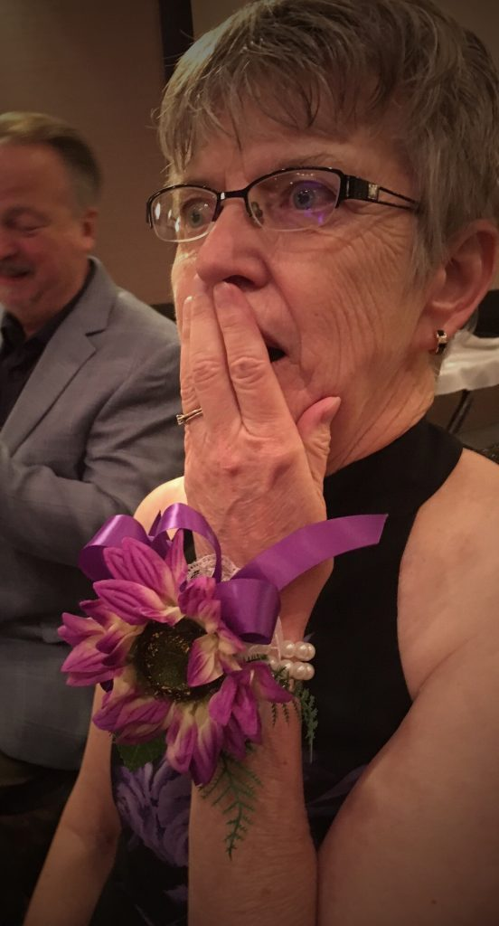
NMPW President Loretta Hall, an Albuquerque freelancer, was named national Communicator of Achievement during the NFPW conference in Wichita, Kan., winning in a field of 11 nominees. (Thanks to Kay Grant for her photo.)
It’s the highest honor bestowed by NFPW and recognizes recipients for exceptional achievement in the communications field, as well as service to NFPW and to the community.
For NMPW, she’s also been Zia Book Award chair and treasurer.
“Loretta stood out to me with the sheer quantity of her professional work, as well as the fact that her chosen topic was in a male-dominated industry,” said a contest judge. “Her long and varied list of community activities earned her top points in that category, and her current and upcoming leadership positions in NFPW also earned her the highest score in that category.”
A former high school mathematics teacher, Hall has written seven nonfiction books and numerous articles for magazines and technical publications. A favorite subject is space exploration, its history and New Mexico’s role in the development of space travel.
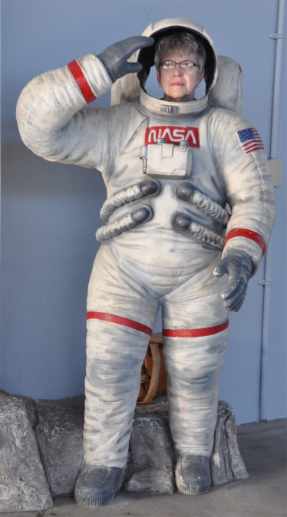
One of Loretta’s goals is to make technical information interesting and understandable to the general public. Her 2014 book, Space Pioneers In Their Own Words, won the science category in the 2014 New Mexico-Arizona Book Awards. Her 2011 book, Out of This World: New Mexico’s Contribution to Space Travel, won first place (nonfiction book, general) in the NMPW communications contest.
Hall is a frequent public speaker. She has been one of the top presenters among 900 participants in the National Space Society’s Space Ambassadors program, giving talks to inspire people about space exploration. She finished fourth among the finalists at the International Space Development Conference, which enables her to participate in suborbital spaceflight training at the National Aerospace Training and Research Center and ride the 25-foot arm centrifuge in simulated spaceflight.
NMPW is important, she says. “In our short-attention-span, sound-bite society, I believe it is more important than ever to promote good journalism and work toward a more informed public.”

NMPW News
For next year’s conference in Las Cruces, Cassie McClure is talking to Sam Quiñones, author of “Dreamland” and former LA Times staffer. The venue will probably be La Posta de Mesilla. At least two concurrent tracks of programming are being planned, with the theme “Cuentos de la Frontera: Opportunities, Challenges and Responsibilities of Telling Stories on the Border.”

Treasurer Peter St. Cyr said that, as of the end of August, the organization’s bank account balance was $7,040.51.

Vice President and Membership Chair Kathy Cordova reports that we have 1 premium member, 1 life member, 55 professional members, 2 student members, and 12 retirees. Nonrenewals totaled 53, which is fairly typical because many people join only to enter the contest.
“With the Communications Contest in gear, I suspect that some of the non-renewing members will re-join the organization,” Kathy says.

The 2017 Zia Book Award will be for children’s literature published by a New Mexico woman author in 2014, 2015 or 2016. Jessica Savage, chair of the Zia Book Award Committee, will begin accepting submissions in November 2016.

Scholarship chair Desiree Cooper will use social media to publicize the NMPW scholarships. And Damien Willis and Cassie McClure volunteered to judge applications.

NMPW Chapters
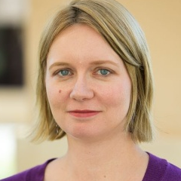
Las Cruces Press Women had an annual membership meeting Sept. 24, which President Cassie McClure described as journalists drinking beer and wandering around her back yard. It was supposed to end at 7 p.m. and really ended at 11 p.m. “I’m personally still recovering,” says President Cassie McClure. Tom Johnson, of the Society of Professional Journalists, spoke. (Ed. Note: Cassie is onto something here. Want to increase meeting attendance? Provide beer.)
On October 27, LCPW will host two German journalists on a fellowship exchange for a panel on reporting in Europe and the refugee crisis. In November, the chapter will host a presentation from a rep from the local Green Chamber of Commerce on business plans for freelancers.

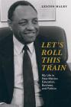
The Albuquerque chapter has changed its name to Albuquerque Press Women and Friends. The chapter and NMPW shared a table at the 12th annual MARCOM Mixer on Oct. 12. “We were the only women there in sensible shoes. But it was a friendly crowd, and lots of people asked about what we do,” said Sherry Robinson. Robinson even won margarita mix in an event drawing.
APW&F most recently heard educator Lenton Malry, New Mexico’s first African-American state representative and Bernalillo County’s first African-American Commissioner. He recently completed his autobiography, Let’s Roll This Train, and joined APW&F.

In Memoriam
Doug Swift, who served APW as treasurer for 10 years, recently passed away at age 90. Doug and his wife Jane made it a mission to help organizations they believed made a difference. We’re honored that they chose us.

NFPW Conference
Loretta Hall reports: The Kansas Professional Communicators chose the theme “Kansas Frontiers” for the 2016 National Federation of Press Women Conference, which was held in Wichita on September 8-10. The organizing committee explained two aspects that theme represented. One was the Old West frontier nature of their state, and the other was the individual frontiers communications professionals face in their careers. Examples of those frontiers include being laid off and deciding to start one’s own communications business, having to learn new skills like website design and social media prowess, or needing to develop leadership skills after being promoted to a more managerial position.
In a special session at the conference, I had the honor of representing NMPW’s Lisa Lenard-Cook at a memorial service for NFPW members who passed away in the past year.
One of the best benefits of attending an NFPW conference is the camaraderie, and this year was no exception. Talking with fellow communicators from across the country brings new perspectives, fresh ideas for dealing with problems, and reassurance that others share our experiences.
Next year’s NFPW Conference will be in Birmingham, Alabama, on September 7-9. Think about going. If you are an NFPW member and have never been to the organization’s annual conference, you can apply for a “first timer grant” to cover your registration fee. Try it; you might like it.

Communication Tools
To help your political reporting, New Mexico In Depth is offering The Openness Project, in the belief that each of us should have the same access to information as those who wield power. The Openness Project makes it easy to search for candidates or political action committees.

Harvard’s Shorenstein Center provides good background on current issue and is available free. See http://journalistsresource.org/

Member Notes
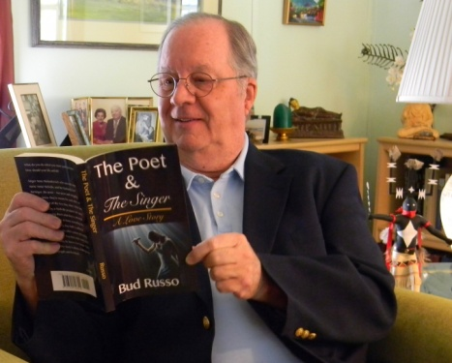
Bud Russo has published his first mainstream novel, The Poet & The Singer.
The idea for the story came during an evening of playing card games with neighbors in Louisville, Kentucky, where Russo heard Neil Sedaka’s song, “The Hungry Years,” with its poignant lyric, “Everything we wanted was everything we had.” That combined with the popularity of singer Anne Murray and a 1970s poet got him thinking on his daily commute.
It took years of writing and rewriting to complete the book. “Now I’m hoping to be an ‘instant success,’” Bud says.
The Poet & The Singer is an e-book available from amazon.com. It is also available as a paperback from on-line booksellers and lulu.com.

Here’s a bit of nostalgia. Linda Harris ran across this clipping from the 1980s.
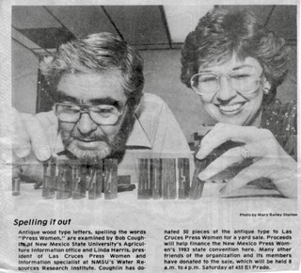

Las Cruces Magazine recently thanked contributors to the recent issue, including Cheryl Fallstead, Cassie McClure, Jessica Savage, and Bud Russo.

Finalists in the 2016 New Mexico-Arizona Book Awards are Sharon Niederman, Farm Table Cookbook; Anne Hillerman, Rock with Wings; Rudolfo Anaya, The Sorrows of Young Alfonso and Poems from the Rio Grande; Barbe Awalt, Ultimate Green Chile Cheeseburger Bucket List; and Loretta Hall, Complete Space Buff’s Bucket List.

NFPW honored two NMPW members for reaching membership mile markers: Sherry Robinson, for 40 years, and Susanne Burks, for 30 years.

Events
The 10th anniversary of the New Mexico-Arizona Book Awards will be celebrated at a gala bash and banquet at Tanoan Country Club on Nov. 18. Anyone who has entered the book awards program over the past ten years is encouraged to attend.

Sharon Niederman will be a speaker in “The Women On The Mother Road in New Mexico: Route 66 Oral Histories and Screening and Discussion Program” on Oct. 26 at 5:30 at the Indian Pueblo Cultural Center in Albuquerque. It’s free to the public.

Southwest Writers will hold a Self-Publishing Conference on Oct. 22 at the New Life Church on Eubank in Albuquerque. See southwestwriters.com for details.

Send your news to Sherry Robinson at robinson@nmia.com.

NMPW Board
PRESIDENT
Loretta Hall
Albuquerque, NM 87104-3059
loretta@authorhall.com

VICE PRESIDENT
Kathryn Cordova
El Prado, NM 87529
midgecordova@hotmail.com

SECRETARY
Damien Willis
Las Cruces, NM
damienwillis@gmail.com

TREASURER
Peter St. Cyr
Albuquerque, NM 87154
peter.stcyr@gmail.com

BROADSHEET EDITOR
Sherry Robinson
Albuquerque, NM 87107
robinson@nmia.com

COMMUNICATIONS CONTEST
Bud Russo
Las Cruces, NM 88001
budrusso@comcast.net

COMMUNICATOR OF ACHIEVEMENT
Diana Sandoval
Los Lunas, NM 87031
dmcsandoval@gmail.com

2017 CONFERENCE CO-CHAIR
Cassie McClure
Las Cruces, NM
cassiemcclure@gmail.com

HIGH SCHOOL CONTEST
Chris Burroughs
Albuquerque, NM 87109
coburroughs@cybermesa.com

NEW MEDIA CHAIR
Karen Wentworth
Albuquerque, NM 87113
karen.wentworth3@gmail.com

PUBLIC RELATIONS
Sharon Niederman
Raton, NM 87740
sherites@swcp.com

SCHOLARSHIP
Desiree Cooper
Roswell, NM 88203
desiree.m.cooper@enmu.edu

ZIA BOOK AWARD & 2017 CONFERENCE CO-CHAIR
Jessica Savage
Las Cruces, NM 88001
jsavage@cybermesa.com

