The Broadsheet
New Mexico Press Women May 2018 Vol. 41 No. 3
Old friends, new ideas at Santa Fe conference
New Mexico Press Women’s 2018 annual spring conference showcased writers and writing in Santa Fe.
Conferences are a chance to catch up with old friends. And we find that no matter how experienced we think we are, we can always learn something new.
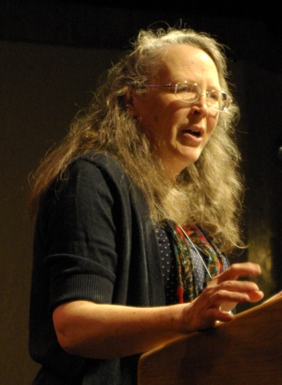
It began with a conversation between author Hampton Sides (Blood and Thunder, Ghost Soldiers, among others) and Sherri Burr.
Sara Solovich, editor of Searchlight New Mexico, who explored a new path for journalists who want to work on longer investigative pieces.
A panel discussion on creating narratives featured Cindy Nava, a DACA recipient and national motivational speaker who writes for the Huffington Post; Karen Jones Meadows, a nationally known playwright whose play “Harriet’s Return: Based Upon the Legendary Life of Harriet Tubman has been performed throughout the world”; and Lorene Mills, host of “Report from Santa Fe.”
Simon Romero, Southwest Bureau Chief for the New York Times, brought a disturbing perspective to current effects.
Caroline Fraser
Our banquet speaker was Caroline Fraser, who had just won the Pulitzer Prize for biography for Prairie Fires: The American Dreams of Laura Ingalls Wilder.

Jessica Savage honored as Communicator of Achievement
Jessica Savage, of Las Cruces, is the 2018 Communicator of Achievement.
A scholarship advisor in the College of Arts and Sciences at New Mexico State University, she oversees scholarships for more than 300 students in 24 departments. She is also the media and communications director for the National Public Observatory, publicizing astronomy outreach programs.
Jessica, an award-winning journalist with 17 years of experience in media relations, has also contributed to Desert Exposure and Las Cruces Magazine.
She has extensive experience in data management and retrieval systems, including a position with the Chihuahuan Desert Network, an inventory and monitoring arm of the National Park Service.
For NMPW, Jessica has been Zia Award chair and is currently public relations chair.

Zia Award presented to Northern New Mexican
Anita Rodriguez, a Ranchos de Taos author whose culturally divergent family melded around recipes, won the Zia Book Award for her Coyota in the Kitchen: A Memoir of New and Old Mexico (UNM Press, 2016).
"I wanted to write about my family," she said. "I wanted to write about New Mexico. I wanted to write about cultural conflict and confluence."
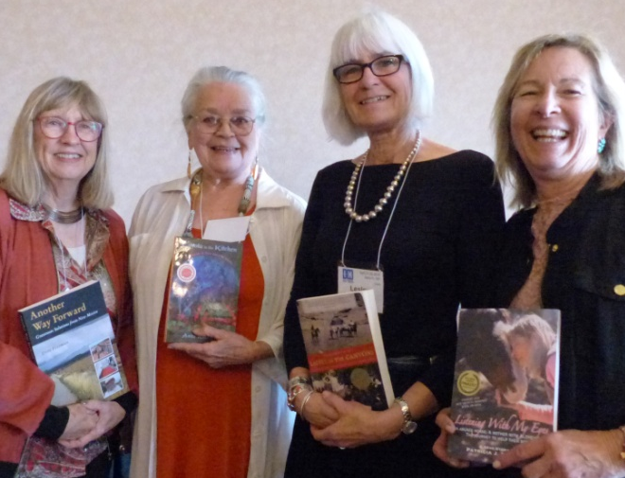
Her father was a dirt-poor northern New Mexican, and her mother, a Southern aristocrat.
"The family was so disparate, we covered such a wide range of classes and cultures, that there seemed no way to tie together all these stories except with something that all us had in common," she said. "That was food.”
Zia finalists were:
- Patricia J. Conoway, of Cerrillos, Listening With My Eyes: An Abused Horse. A Mother with Alzheimer's. The Journey to Help Them Both.
- Dede Feldman, of Albuquerque, Another Way Forward: Grassroots Solutions from New Mexico.
Dede Feldman, Anita Rodriguez, Lesley Poling-Kempes, Patricia Conoway
- Lesley Poling-Kempes, of Abiquiú, Ladies of the Canyons: A League of Extraordinary Women and Their Adventures in the American Southwest.
Zia Chair Bill Diven accepted 29 nonfiction entries and disqualified two others.

2018 New Mexico Press Women Elected Officers
New officers elected by acclamation are President Sherri Burr, Vice President Damien Willis, Treasurer Loretta Hall, and Secretary Carol Kreis.
They serve for two years.
Sherri Burr is the Regents Professor of Law at UNM Law School, where for 30 years she taught intellectual property law, art law, entertainment law, international law, among other courses. She was also producer and host of “ARTS TALK,” a weekly television show. She is an award-winning author of numerous legal and business books. Now retired, Sherri is writing a book tentatively titled “The Free Blacks of Virginia: Personal Narrative, a Legal Construct."
Sherri was a Communicator of Achievement in 2014 and former NMPW vice president and First Amendment chair.
Damien Willis is director of communications for the Las Cruces Public School District. Previously, he was public information officer of the Third Judicial District Attorney’s Office and education reporter for the Las Cruces Sun-News. He’s written an entertainment and pop culture column in the Sun-News for over 13 years.
Damien has been secretary of Las Cruces Press Women for five years and NMPW for two years.
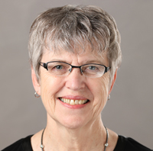
Loretta Hall has written eight nonfiction books, the last four of which were about outer space travel, as well as numerous magazine articles and book chapters. Loretta is immediate past president and a former treasurer and Zia Book Award chair. She was named the 2016 NMPW and National Federation of Press Women Communicator of Achievement.
Carol Kreis has been an educator, public relations coordinator for the Rio Grande Zoo, and a writer and researcher of educational materials for the Newsweek Education Program. She managed the Newspapers-in-Education program for the Albuquerque Journal and the Tribune and was a founding co-director of UNM’s Rio Grande Writing Project.
Carol has been NMPW treasurer and was Communicator of Achievement in 2013.

New president announces plans for the coming year
President Sherri Burr wants NMPW to host a convention of the National Federation of Press Women in 2021.
“The last national conference in 1980 brought close to 300 journalists from around the nation to our state and netted a healthy balance to the NMPW treasury,” she says.
Sherri wants to reinvigorate the High School Contest by securing a sponsor to pay all the fees and a chair with connections to the high schools with journalism programs.
She also wants to work with chapters to identify speakers of interests to journalists and writers in attractive venues.

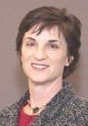
Communications Contest Winners Announced
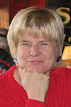
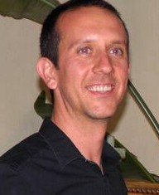
Megan Kamerick won first place in overall excellence for her awards in the 2018 Communications Contest. Heath Haussamen was second in individual overall excellence, and Ruth Friesen was third. Colleen Keane and Sherry Robinson tied for an honorable mention.
The overall excellence award is tallied on points earned in individual categories. Ruth was one point behind Heath, and Colleen was two points behind Ruth.
Megan Kamerick, Heath Haussamen, Ruth Friesen
In organizational awards, New Mexico Political Report won first place for overall excellence, Rio Grande Books was second, and New Mexico In Depth was third.
NMPW received 173 entries from 58 entrants in 126 categories in the annual communications contest.
Chair Carolyn Carlson recruited judges from across the nation, including journalism professors and other educators, working broadcasters from top markets, published authors, award-winning public relations professionals, and other accomplished media professionals.
“From what I could see, New Mexico has abundant talent with many excellent people doing great work on all kinds of media platforms,” Carolyn said.

Here are the awards listings by category:
News story, print newspaper: 1. Xchelzen Peña, New Mexico In Depth, “Hopes and Fears: One DACA Recipient's Story”; 2. Trip Jennings, New Mexico In Depth, “Closed Loopholes, Medicaid Cuts and Potential Higher Health Insurance Costs Buried in Gov. Supported Bill”; 3. Colleen Keane, Navajo Times, “Jaa’abani’ Needs Help, Now!”; HM Colleen Keane, “No DAPL protesters: Divest!” and “Facebook and Twitter are not enough.”
Online newspaper: 1. Andy Lyman and Joey Peters, New Mexico Political Report, “Two Iraqi Refugees In NM Helped US Military, Now They're Facing Deportations”; 2. Heath Haussamen, NM Political Report, “A Day After Charlottesville for News Story,” and 3. Heath Haussamen, “Layoffs Hit Las Cruces Sun-News.”
Continuing coverage or unfolding news: 1. Marjorie Childress, New Mexico In Depth, “Money in Politics in the Albuquerque Mayoral Race”; 2. Andy Lyman, NM Political Report, “UNM Whistleblower Trial Coverage”; 3. Sherry Robinson, Gallup Independent, “Federal Grand Jury indicts,” “Same Names Come Up in Fake Indian Jewelry,” “For Special Agent, rooting out fake Native Jewelry.”
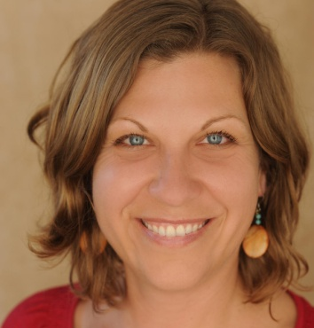
Investigative reporting: 1. Heath Haussamen, NM Political Report, “Distressed: A look At Behavioral Health In Southern NM”; 2. Tie, Heath Haussamen, “Is Spaceport America Taking Flight?” and Jeff Proctor, Trip Jennings, Marjorie Childress, New Mexico In Depth, “Stung in Albuquerque”; 3. Tie, Sherry Robinson, Gallup Independent, “Utah Navajo Health System Directors Profit,” “UNHS Bonuses the smell of success?” and Laura Paskus, NM Political Report, “State Remains Silent on Lead Poisoning Data.”
Enterprise reporting: 1. Laura Paskus, NM Political Report, “Up In Smoke: Opportunities on Climate, Renewables Shunned during Martinez Administration”; 2. Jeff Proctor, New Mexico In Depth, “Throwing Away the Key: New Mexico's 30-year Lifers Denied a Fair Shot at Parole”; 3. Trip Jennings and Sylvia Ulloa, New Mexico In Depth, “The Slow Motion Unraveling of New Mexico's Medicaid Crackdown.”
Editorial/Opinion, print newspaper: 1. Rudolfo Carrillo, Weekly Alibi, "Mijo, I'm Sick"; 2. Sharon Hendrix, Albuquerque Journal, "Archdiocese' Disclosure a Step Toward Global Healing"; 3. Sylvia M. Ramos, Albuquerque Journal, “Nondisclosure Agreements Must Go”; HM Dan Vukelich, ABQ Free Press, “Social Media as Weaponry.”
Laura Paskus
Editorial/opinion, online publication: 1. Janet K. Brennan, JB Stillwater Literary Magazine, Chicken Soup for the Soul, Taj Mahal Review, The Poetry Magazine, Insights Magazine, “A Myopic View of Existentialism.”
Feature story, print newspaper: 1. Coleen Keane, Navajo Times, “Jaa’abani’ needs help, now!”
Feature story, magazine, newsletter, or other print publication: 1. Loretta Hall, Air and Space Smithsonian, “Space Tourists Like Us”
Feature story, online publication: 1. Andy Lyman, NM Political Report, “It Runs In The Family; Decades Apart, Father and Son Lead Sanctuary Efforts”; 2. Laura Paskus, NM Political Report, “The Heart of Darkness: A Walk Through The Scorched Landscapes”; 3. Heath Haussamen, NM Political Report, “Brewery Helps Breathe New Life Into Downtown.”
Personality profile, fewer than 500 words: 1. Melody Groves, Enchantment Magazine, “Milton J. Yarberry, Jerked to Jesus” and HM, “She grew up to be a knight.”
Personality profile, more than 500 words: 1. Wendel Sloan, “Professor’s Life Filled With Music,” 2. Colleen Keane, “Dine Students Honor Family”; 3. Diane Schmidt, “A Visit with Rabbi Evelyn Baz”: HM Matthew Reichbach, NM Political Report, “A Moral Choice.”
Specialty articles, business: 1. Marie C. Baca, Albuquerque Journal, “Amazon Bursts Into Groceries” and “For Many, Medicare Costs offset Social Security Raise”; 2. Sherry Robinson, Gallup Independent, “Feds: Fake Jewelry Has Big Names.”
Specialty articles, education: 1. Joey Peters, NM Political Report, “APS Facing Federal Scrutiny For Handling of Disabled Student” and “State College Exchange Program Sees Cuts Amid Budget Troubles”; 3. Sylvia Ulloa, New Mexico In Depth, “Education in New Mexico.”
Specialty articles, government or politics: 1. Andy Lyman, NM Political Report, “Source of Lewis' Attack Line: Santolina Exec, Not Newspaper” and “Youth Aren't Just Watching, They're Running for Office”; 2. Matthew Reichbach, “A Big Cost to NM If Congress Doesn't Act On Children's Health Program” and “New Mexico Reserves Among Lowest in the Nation.”
Special articles, environmental: 1. Laura Paskus, NM Political Report, “Running Dry: Groundwater Levels Are Dropping Across the West.”
Special articles, history: 1. Dianne Layden, LEGACY, Newsletter of the New Mexico Jewish Historical Society, “Albuquerque Holocaust Survivors Honored,” parts 1 and 2; 2. Sherry Robinson, Wild West, “Horsehead Crossing on the Pecos” and La Cronica, “Little Known Bankhead Highway Linked Two Coasts.”
Special articles, religion: 2. Diane Schmidt, NM Jewish Link, “A Jewish and Navajo Marriage.”
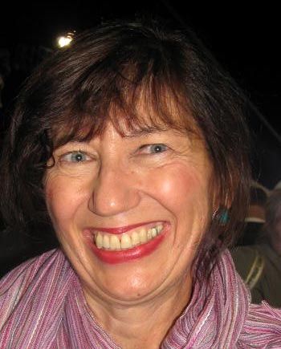
Special articles, reviews: 1. Loretta Hall, National Space Society, “Picture This” and “Amazing Stories of the Space Age.”
Special articles, social issues: 1. Colleen Keane, Navajo Times, “Justice Undone” and “Three Years After, Urban Indian Population Remains Vulnerable”; 2. Diane Schmidt, NM Jewish Link, “Muslims and Jews Unite.”
Special articles, travel: 1. Thomas Reavey Jr., N Magazine, “Las Cruces, New Mexico” and “A Visit to Trinity Site; 2. Evan Belknap, Sandoval Signpost, “Time off, Snow Caves” and “Time off, Wondering, Looking.”
Columns, general: 1. Patricia Dobson, Eastern NM News, “Keep your near, dear ones close” and " Love shines when you let past go; 2. Colleen Keane, Navajo Times, “Donaldson shares lessons learned” and “Book provides a view of Navajo from Belfast”; 3. Wendel Sloan, Portales News Tribune, “Other side of tragedy is profound beauty” and “Seems my father had life figured out”; HM Claudette Sutton, Tumbleweeds, “A Very Special Ant” and “Going Big.”
Colleen Keane
Columns, personal opinion: 1. Sherry Robinson, New Mexico News Services, “Talking About Accountability Is Easier Than Being Accountable” and “How Poor Do We Want To Be?”; 2. Heath Haussamen, NM Political Report; 3. Merilee Dannemann, New Mexico News Services, “Governor doesn’t seem interested” and “Recent shooting”; HM Anna Redsand, Gallup Independent, “The Flow of Ministry” and “Be the Light” and Sherry Robinson, New Mexico News Services, “After 43 years of sexual harassment.”
Publications regularly edited by entrant, newspaper: 1. Barb Belknap, Sandoval Signpost.
Publications regularly edited by entrant, magazine, newsletter, or other publication: 1. Claudette Sutton, Katy Yanda and Steve Harrington, Tumbleweeds Newspaper for Santa Fe Families.
Sherry Robinson
Single photograph, news or feature: 1. Ruth Friesen, Wagon Tracks, “Wagon Wheel,” 2. Ruth Friesen, “Praying for a View”; 3. Ruth Friesen, “Total Eclipse.”
General photo: 1. Ruth Friesen, Wagon Tracks, “Rainy Roman Afternoon”
Photo essay: 1. Helena de la Paz, “Spirit Collage”; 2. Ruth Friesen, Wagon Tracks, “Total Eclipse along the National Historic Trails.”
Photographer-writer: 1. Merimee Moffitt and Georgia Santa Maria, Berlin Poems and Photographs” 2. Heath Haussamen, “Protesters Confront Border Patrol”; 3. Ruth Friesen, Wagon Tracks, “Hot Tire for a Wagon Wheel”: HM Ruth Friesen, “Symposium 2017 at Olathe, Kansas.”
Book designed by entrant: 1. Jesse Ehrenberg, Surprise.
Prepared report, radio: 1. Megan Kamerick and Acacia Squires, KUNM, “Schools Will Soon Have to Put in Writing If They Lunch Shame”; 2. Megan Kamerick and Nina Gregory, KUNM, “With This Publisher Native American Superheros Fly High.”
Prepared report, television: 1. Kathleen McCleery, PBS News Hour, “A Firehouse Answers The Call for Health Care”; 2. Megan Kamerick and Nina Gregory, KNME, “Passions Flare Over Memory of Manhattan Project”; 3. Megan Kamerick and Nina Gregory, Native Americans Tell Their Own Superhero Stories At Indigenous Comic Con.
Special programming, television: 1. Megan Kamerick and Sarah Gustavus, KNME, “Preparing for The End of Life.”
Interview, radio or television: 1. Megan Kamerick, “Book Details Tragic Story of Shining Girls Poisoned by Radium”; 2. Megan Kamerick and Tara Walch, “Maria ‘Masha’ Alyokhina of Pussy”; 3. Leora Zeitlin, KRWG-FM, “Irish Fiddle Master Brian Conway”; HM Leora Zeitlin, “Legendary pianist Misha Dichter” and HM Megan Kamerick, “Women in Technology.”
Talk show, radio or television: 1. Megan Kamerick and Elaine Baumgartel, Bidding for Corporate Development; 2. Megan Kamerick, “Genizaros and New Mexico's Legacy of Slavery”; 3. Megan Kamerick, “Where Research Meets Community to Create Change.”
Website edited or managed by entrant, nonprofit, government, or educational: 1. Kira Sadler, “Voices for Biodiversity”; 2. Diana M. Sandoval-Tapia, Aileen O’Catherine and Elizabeth Peralta, New Mexico Workers' Compensation Administration Official Website; 3. Rose Marie Kern, Southwest Writers Website.
Blogs, nonprofit, government, or educational: 1. Michelle Worley, “East Mountains Area Goes Vegan” and “Nostalgia for Christmas in Madrid, NM.”
Blogs, personal: Norine Dresser, “Norine's New Life @ 80”; 2. Shirley Melis, “Tips on Writing a Memoir” and “On Working with an Editor”; 3. Merilee Dannemann, “Local Employment Rules” and “Love Horses.”
Social media campaign, nonprofit, government, or educational: 1. Julie Abbiss, Facebook and Instagram, “Five Days of Gender Violence.”
Videos for website, nonprofit, government, or educational: 1. Circe Olsen Woessner, Military Family Museum website, “Military Family Stories.”
Videos for website, corporate or for-profit: 1. Marisela Angulo Tucker, Art Tucker and Shirley Melis, www.shirleymelis.com, “Banged-Up Heart Book Trailer.”
Videos for website, special-interest: 1. Marisela Angulo Tucker, Art Tucker and Rebecca Fitton, www.rebeccapottfitton.com, “Wave Rider” book trailer.
PR materials, newsletters: nonprofit, government, or educational: 1. Marisela Angulo Tucker and Andrea Cassutt, Santa Fe Youth Symphony Monthly Newsletter; 2. Marisela Angulo Tucker and Leanne DeVane , Santa Fe Public Schools Music Department Newsletter; 3. Rose Marie Kern, Southwest Sage Newsletter.
Catalogs, manuals, and handbooks: 1. Diana M. Sandoval-Tapia and Aileen O’Catherine, Workers Compensation Administration, Worker Guidebook.
Speech: 1. Claudette Sutton and Javier Baros, “From Duck Dynasty to Diploma”; 2. Melody Groves, “Five Things I Wish I'd Known Before I Started A Writing Career.”
Claudette Sutton
Collegiate writing, news: 1. Robert Salas, New Mexico In Depth, "UNM Grads are Leaving the State”; 2. Melorie Begay, "Fracking Boom Leads to Tension in Navajo Communities.”
Novels for adult readers: 1. Anne Hillerman, Harper Collins, Song of the Lion; 2. Joanne S. Bodin, Mercury Heartlink, Orchid of the Night; 3. Janet Greger, Askenbaaken and Kent, Riddled With Clues; HM Janet Greger, She Didn’t Know Her Place.
Books, biography or autobiography: 1. Iris Keltz, Nighthawk Press, Unexpected Bride in the Promised Land; 2. Shirley Melis, Terra Nova Books, Banged Up Heart, Dancing with Love.
Books, history: 1. Richard Melzer, Rio Grande Books, Capt. Maximiliano Luna: A New Mexico Rough Rider; 2. Joseph Sanchez and Anglelica Sanchez-Clark, Rio Grande Books, Historical Route 66: A New Mexican Crossroads; 3. Robert Torrez, Rio Grande Books, Voices From the Past: The Comanche Raid of 1776 and other Tales of New Mexico History; HM Richard Melzer and John Taylor, Rio Grande Books, Tragic Trails and Enchanted Journeys.
Anne Hillerman
Books, travel: 1. Riley Mitchell, Rio Grande Books, The Essential Paranormal Bucket List; 2. Slim Randles, Rio Grande Books, The Fly Fisherman's Bucket List.
General nonfiction: 1. Dede Feldman, Dede Feldman Co., “Another Way Forward: Grassroots Solutions From New Mexico; 2. Rose Marie Kern, Solar Ranch Publishing, Air to Ground.
Children’s books, fiction: 2. Kathy Schuit, Kathy Schuit Publishing, Where Does This Line Go: Penndittle E. Turtle Wants To Know; 3. Barbe Awalt, Rio Grande Books, T'adoo naaldbos wolt'a'i bidilnihi - Don't Touch This Book and Barbe Awalt, Rio Grande Books, No Toques Este Libro! Don't Touch This Book; HM Loretta Hall, Rio Grande Books, Miguel & Michele Visit Spaceport America and Rachel Bate, Desert Bliss.
Children’s books, nonfiction: 1. Ross Van Dusen, Rio Grande Books, What Makes the Lightning?
Short story: 2. Rita A. Popp, Wildside Press, “Ping Pong Girl”; 3. Terry Rose, Oasis Journal, My Driver's License Photograph; HM Patricia Walkow, The View from the Office.
Short story collection: HM Janet Gregor, Other People’s Mother.
Single poem: 3. Sylvia Ramos Cruz, Encore: Prize Poems, Memorial Day 2016: Montefiore Jewish Cemetery, Las Vegas, NM
Book of poetry: 2. Jesse Ehrenberg, Foothills Publishing, Surprise.
Essay, chapter, or section in a book: 1. Sylvia Ramos Cruz, Beatlick Press, Trilogy: Thoughts on Price, Value, Worth; 2. Chris Allen, Maureen Cooke and James Tritten, RhetAskew Publishing, To Begin Again; 3. James Tritten and Sandi Hoover, RhetAskew Publishing, Enough To Kill; HM James Tritten, “Round Engines.”
Book edited by entrant: 3. Chris Allen and Sandi Hoover, Corrales Writing Group and Create Space, Passages: A Corrales Writing Group Anthology.

NMPW awards two scholarships
Two University of New Mexico students received Doris Gregory Memorial Journalism Scholarships.
Ludella Awad and Marco Torrez are both studying broadcast journalism with the goal of working in television.
While still in high school, Ludella wrote and published four books, including a poetry collection, “Sad Piano Music in Syria.” She is a Daily Lobo advertising representative and has published articles in the Lobo, as well as the Albuquerque Journal. She is interested in all forms of journalism and writing including print journalism and photo journalism.
Marco served as an intern at KOB News 4. He hopes to work in television news, both nationally and internationally.

First Amendment Report
The U. S. Supreme Court agreed to hear seven First Amendment cases during the 2017-2018 term, writes former First Amendment Chair Sherri Burr. Among the most discussed cases involved gerrymandering in Wisconsin and Maryland, whether pregnancy centers have to give advice on abortion, and Masterpiece Cakeshop v. Colorado Civil Rights Commission, involving the right of a cake baker to refuse to make a cake for a gay couple. All cases will be decided by June 30th at the close of the term.
Also of interest: the continuing challenges to journalistic integrity under the guise of “fake news,” an op-ed penned by retired justice John Paul Stevens urging the repeal of the Second Amendment that permits the right to carry arms, and Texas v. New Mexico v. Colorado, in which the Supreme Court granted the federal government the right to intervene to determine whether New Mexico had violated the Rio Grande Compact.

Chapter News
The Northern New Mexico Chapter’s bimonthly luncheons have featured Collin Haffey, fire ecologist of the U.S. Geological Survey New Mexico Landscapes Field Station, talking about the impact of fires, the history of fires in the region, and the concept of “fire adapted communities.” Author Melody Groves gave a presentation, “Westerns: Alive and Kickin'--Yee Haw!” Julie Ann Grimm, Santa Fe Reporter editor and publisher, talked about her newspaper in “Scrappy, Snarky and Strong,” and Santa Fe New Mexican Editor Phill Casaus, shared his vision for the newspaper.

Albuquerque Press Women & Friends’ monthly luncheons have heard Tara Gatewood, host of the KUNM talk show “Native America calling,” discussed Native American issues. Former State Land Commissioner Ray Powell talked about public lands and the current campaigns for land commissioner. Linda Atkinson, founder of the DWI Resource Center, addressed the continuing problem of DWI in New Mexico. And Colin Baillio, policy director of Health Action New Mexico, discussed his organization’s priorities.

NMPW Board
PRESIDENT
Sherri Burr, Albuquerque, president@newmexicopresswomen.org

VICE PRESIDENT
Damien Willis, Las Cruces, damienwillis@gmail.com

SECRETARY
Carol Kreis, Albuquerque, Carolkreis@comcast.net

TREASURER
Loretta Hall, Albuquerque, loretta@authorhall.com

COMMUNICATIONS CONTEST
Carolyn Carlson, Albuquerque, carolyn@thecitizenmediagroup.org

BROADSHEET EDITOR
Sherry Robinson, Albuquerque, robinson@nmia.com

COMMUNICATOR OF ACHIEVEMENT
Diana Sandoval, Los Lunas, dmcsandoval@gmail.com

NEW MEDIA CHAIR
Karen Wentworth, Albuquerque, karen.wentworth3@gmail.com

